Name_________________________________ 01.03 Printing Strings

**This assignment has two parts.**

**Part One: Programming**

Write a program to display a message to the screen. The message may be a poem, song, or information about you. Use the following guidelines to write your program:

1. Use the Python IDLE to write your program.
2. Using comments, type a heading that includes your name, today’s date, and a short description.
3. Decide on the message you would like to display to the screen. Some ideas include:

* Your favorite poem or song
* A few sentences sharing information about you

1. Set up your def main(): statement.
2. Don’t forget the parentheses and colons!
3. Use at least five print statements to display your message to the screen.
4. Conclude the program with the main() statement.
5. Follow the Python style conventions regarding indentation in your program.
6. Run your program to ensure it is working properly. Fix any errors the interpreter or you may observe.

**Example of expected output:** The screen shot below is an example of an “all about me” message. Your specific results will vary depending on the choices you make about your message.

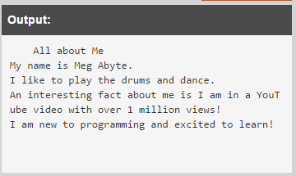

**Insert your program code here:**

**def main():**

**print("All about Me")**

**print("My name is Jonathan Meyer")**

**print("I am a full-stack developer fluent in Java, PY, JS, HTML, CSS.")**

**print("I have been programming for 5 years.")**

**print("In my programming journey I started out with Java making discord bots and minecraft plugins. Then I made an application with Python. Then moved to JS, HTML, and CSS making several websites and applications.")**

**main()**

**Part Two: Post Mortem Review**

Complete the Post Mortem Review (PMR). Write thoughtful two to three sentence responses to all the questions in the PMR chart.

| **Review Question** | **Response** |
| --- | --- |
| What was the purpose of your program? | Tell the user about me. |
| How could your program be useful in the real world? | It could be a way to introduce people to other people. |
| What is a problem you ran into and how did you fix it? | Didn't run into any issues. |
| Describe one thing you would do differently the next time you write a program. | Use less lines. |